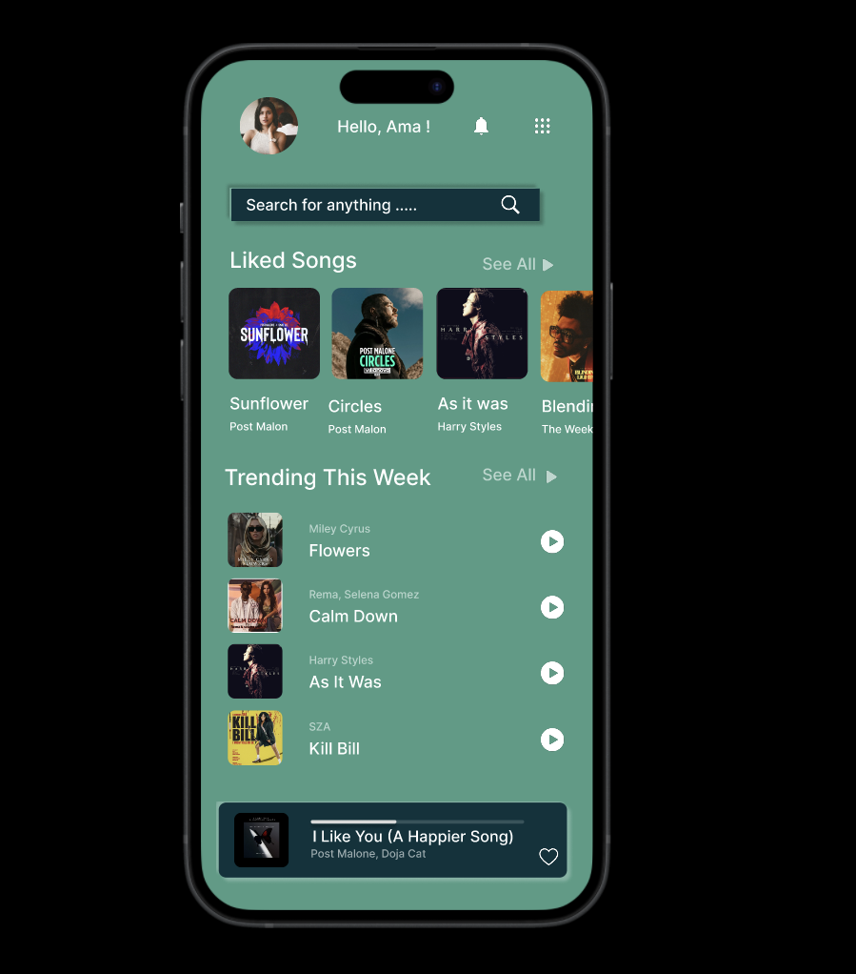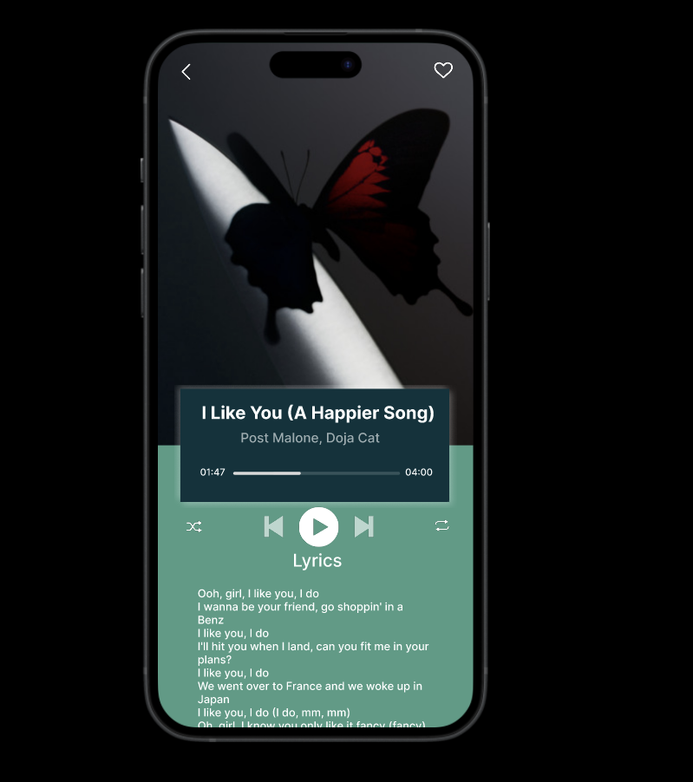Protype Link:

<https://www.figma.com/proto/2ExteUBj47JstWNSvYCNGw/Music-Player?page-id=0%3A1&node-id=55-43&viewport=446%2C648%2C0.31&t=INxTStY82Wg6WvMN-1&scaling=scale-down&content-scaling=fixed>